Insert your name, centre number and candidate number into the header above.
Save this evidence document as evidence_ followed by your centre number_ candidate number. For example: evidence_ zz999_9999.doc
Screenshots or program listings must be copied into appropriate cells in the following tables.
Examiners must be able to read the contents including any screenshots without the use of a magnifying glass. Answers that are not readable or missing will not be awarded any marks.
Save this evidence document at regular intervals, for example, every 10 minutes.
Question 1
Part 1(a)(i)
class EventItem:
def __init__(self, n, t, d):
self.__EventName = n #string
self.__Type = t #string
self.__Difficulty = d #integer

Part 1(a)(ii)
def GetName(self):
return self.__EventName
def GetDifficulty(self):
return self.__Difficulty
def GetEventType(self):
return self.__Type

Part 1(b)(i)
Group = []

Part 1(b)(ii)
Group = [EventItem("Bridge", "jump", 3), EventItem("Water wade", "swim", 4), EventItem("100 mile run", "run", 5), EventItem("Gridlock", "drive", 2), EventItem("Wall on wall", "jump", 4)]

Part 1(c)
class Character:
def __init__(self, j, s, r, d):
self.__Jump = j #integer
self.__Swim = s #integer
self.__Run = r #integer
self.__Drive = d #integer

Part 1(d)
def CalculateScore(self, event, difficulty):
if event.lower() == "jump":
return min(100 - (difficulty - self.__Jump) * 20, 100)
elif event.lower() == "swim":
return min(100 - (difficulty - self.__Swim) * 20, 100)
elif event.lower() == "run":
return min(100 - (difficulty - self.__Run) * 20, 100)
else:
return min(100 - (difficulty - self.__Drive) * 20, 100)

Part 1(e)(i)
Tarz = Character(5, 3, 5, 1)
Geni = Character(2, 2, 3, 4)

Part 1(e)(ii)
def main():
Group = [EventItem("Bridge", "jump", 3), EventItem("Water wade", "swim", 4), EventItem("100 mile run", "run", 5), EventItem("Gridlock", "drive", 2), EventItem("Wall on wall", "jump", 4)]
Tarz = Character(5, 3, 5, 1)
Geni = Character(2, 2, 3, 4)
st = 0
sg = 0
for i in Group:
a = Tarz.CalculateScore(i.GetName(), i.GetDifficulty())
b = Geni.CalculateScore(i.GetName(), i.GetDifficulty())
st += a
sg += b
if a > b:
print(f"Tarz wins the event {i.GetName()}.")
elif a < b:
print(f"Geni wins the event {i.GetName()}.")
else:
print(f"The event {i.GetName()} is a draw.")
if st > sg:
print("Tarz has a higher score.")
elif st < sg:
print("Geni has a higher score.")
else:
print("The group is a draw")

if __name__ == "__main__":
main()

Part 1(e)(iii)
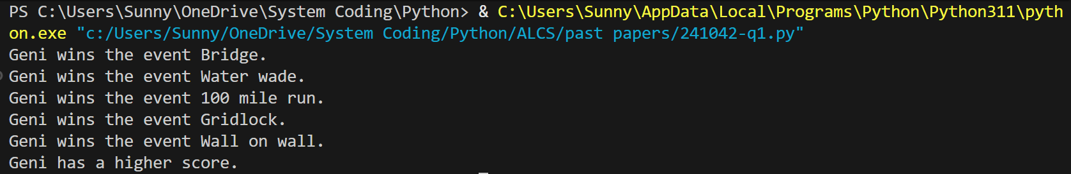

Question 2
Part 2(a)
class Queue:
def __init__(self, arr, head, tail):
self.QueueArray = arr #array of integer
self.Headpointer = head #integer
self.Tailpointer = tail #integer

Part 2(b)
TheQueue = Queue([-1] * 100, -1, 0)

Part 2(c)
def Enqueue(AQueue, TheData):
if AQueue.Headpointer == -1:
AQueue.QueueArray[AQueue.Tailpointer] = TheData
AQueue.Headpointer = 0
AQueue.Tailpointer += 1
return 1
elif AQueue.Tailpointer > 99:
return -1
else:
AQueue.QueueArray[AQueue.Tailpointer] = TheData
AQueue.Tailpointer += 1
return 1

Part 2(d)
def ReturnAllData(AQueue):
res = ""
for i in range(AQueue.Headpointer, AQueue.Tailpointer):
res += str(AQueue.QueueArray[i]) + " "
return res[:len(res) - 1]

Part 2(e)(i)
def main():
TheQueue = Queue([-1] * 100, -1, 0)
for i in range(10):
a = -1
while a < 0:
a = int(input("Enter the number to be added: "))
if a < 0: print("The number must be greater than 0!")
if Enqueue(TheQueue, a) == -1:
print("Queue is full!")
break
print(ReturnAllData(TheQueue))

if __name__ == "__main__":
main()

Part 2(e)(ii)
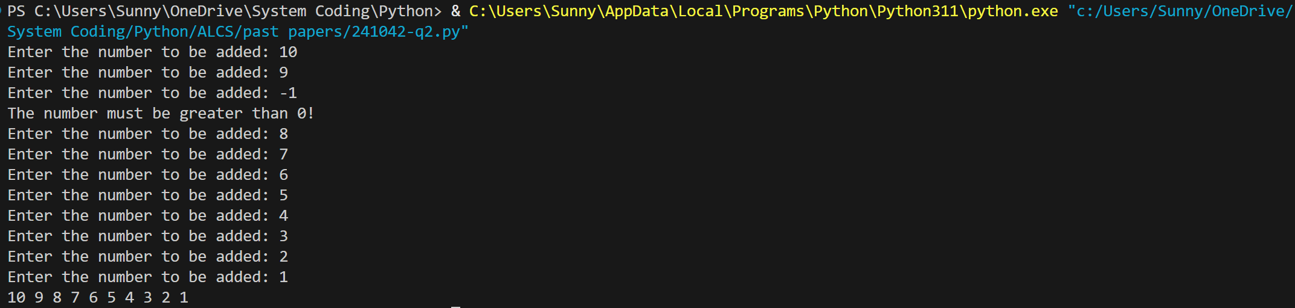

Part 2(f)
def Dequeue(AQueue):
if AQueue.Headpointer == AQueue.Tailpointer:
return -1
res = AQueue.QueueArray[AQueue.Headpointer]
AQueue.Headpointer += 1
return res

Part 2(g)(i)
def main():
TheQueue = Queue([-1] * 100, -1, 0)
for i in range(10):
a = -1
while a < 0:
a = int(input("Enter the number to be added: "))
if a < 0: print("The number must be greater than 0!")
if Enqueue(TheQueue, a) == -1:
print("Queue is full!")
break
print(ReturnAllData(TheQueue))
for i in range(2):
a = Dequeue(TheQueue)
if a == -1:
print("The queue is full")
else:
print(a)

if __name__ == "__main__":
main()

Part 2(g)(ii)
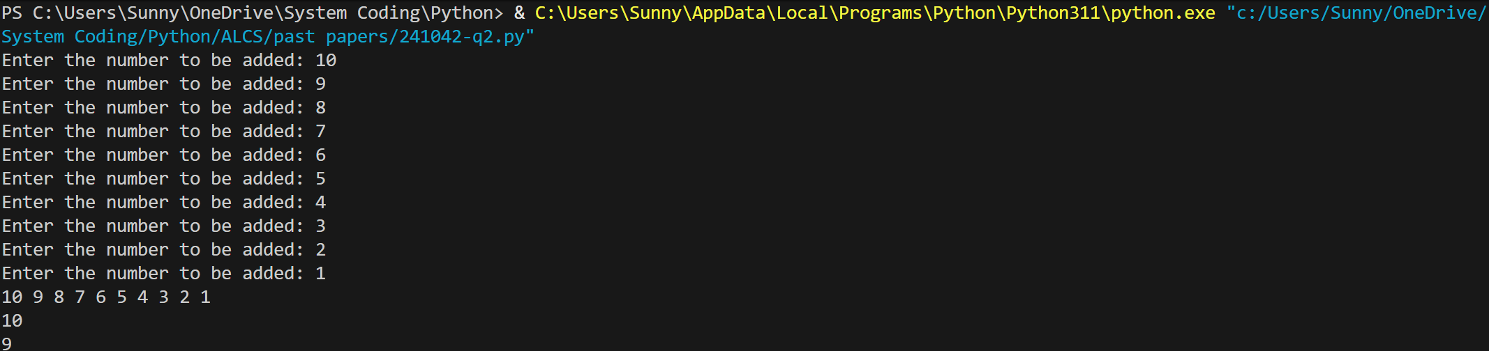

Question 3
Part 3(a)
HighScores = [["" for i in range(3)] for j in range(7)]

Part 3(b)
def ReadData():
res = [["" for i in range(3)] for j in range(7)]
try:
with open("HighScoreTable.txt", "r", encoding = "utf-8") as f:
i = 0
while True:
if i >= len(res):
break
res[i][0] = f.readline().strip()
res[i][1] = f.readline().strip()
res[i][2] = f.readline().strip()
if res[i][0] == "":
break
i += 1
return res
except FileNotFoundError:
print("File does not exist")

Part 3(c)
def OutputHighScores(arr):
for i in arr:
print(f"{i[0]} reach level {i[1]} with a score of {i[2]}.")

Part 3(d)
def SortScore(arr):
sorted = False
while not sorted:
sorted = True
for i in range(len(arr) - 1):
if arr[i][1] < arr[i + 1][1] or arr[i][1] == arr[i + 1][1] and arr[i][2] < arr[i + 1][2]:
sorted = False
arr[i], arr[i + 1] = arr[i + 1], arr[i]
return arr

Part 3(e)(i)
def main():
HighScores = [["" for i in range(3)] for j in range(7)]
HighScores = ReadData()
print("Before")
OutputHighScores(HighScores)
SortScore(HighScores)
print("After")
OutputHighScores(HighScores)

if __name__ == "__main__":
main()

Part 3(e)(ii)
